
NED UNIVERSITY OF ENGINEERING & TECHNOLOGY
Department of Physics
RADAR SYSTEM USING MOTION DETECTION SENSOR
Project Report
Submitted by:
Syed Muhammad Izhaan
Semester: 3rd Semester
Karachi, Pakistan

TABLE OF CONTENTS
1. Abstract --------------------------------------------------------------------------------------------- 4
2. Introduction --------------------------------------------------------------------------------------------- 4
2.1 Background of the Study ----------------------------------------------------------------------------- 4
2.2 Motivation and Problem Statement -------------------------------------------------------------- 4
3. Objectives of the Project ------------------------------------------------------------------------------- 4
4. Theoretical Background ------------------------------------------------------------------------------ 4
4.1 Motion Detection Principle -------------------------------------------------------------------------4
4.2 Ultrasonic Sensor Theory --------------------------------------------------------------------------4
4.3 Time-of-Flight Measurement ---------------------------------------------------------------------4
4.4 Conceptual Comparison with Radar Systems --------------------------------------------------- 5
5. System Design and Methodology ------------------------------------------------------------------- 5
5.1 Block Diagram Description ------------------------------------------------------------------------ 5
5.2 Overall System Architecture ----------------------------------------------------------------------- 5
6. Hardware Components and Specifications ------------------------------------------------------- 5
6.1 Microcontroller (Arduino) ------------------------------------------------------------------------ 5
6.2 Ultrasonic Sensor --------------------------------------------------------------------------------- 5
6.3 Servo Motor --------------------------------------------------------------------------------- 5
6.4 Power Supply and Supporting Components --------------------------------------------------- 5
7. Software Implementation and Simulation -------------------------------------------------------- 5
7.1 Arduino Program Logic -------------------------------------------------------------------------- 5
7.2 Serial Communication ------------------------------------------------------------------------- 5
7.3 Radar Visualization using Processing ------------------------------------------------------- 5
8. Working Principle of the Radar System -------------------------------------------------------- 5
8.1 Signal Transmission and Reception -------------------------------------------------------- 5
8.2 Distance Calculation --------------------------------------------------------------------------- 5
8.3 Angular Scanning Mechanism ---------------------------------------------------------------------- 5
8.4 Data Visualization Process -------------------------------------------------------------------------- 6
9. Results and Observations ---------------------------------------------------------------------------- 6
9.1 Experimental Results ------------------------------------------------------------------------------ 6
9.2 System Accuracy and Limitations ---------------------------------------------------------------- 6
10. Applications of the Proposed System --------------------------------------------------------------6
11. Conclusion ------------------------------------------------------------------------------------------------6
12. Future Enhancements ----------------------------------------------------------------------------------6
13. Appendix ------------------------------------------------------------------------------------------------- 7
A. Arduino Code -------------------------------------------------------------------------------------------- 7
B. Processing Simulation Code -------------------------------------------------------------------------- 8

Project Report: Ultrasonic Radar System
- Abstract
This project involves the design and implementation of a short-range radar system using an ultrasonic sensor and an Arduino microcontroller. The system rotates using a servo motor to scan a 180-degree area, detecting objects and measuring their distance. The data is then sent to a PC and visualized using the Processing IDE, creating a graphical radar interface.
- Introduction
2.1 Background of the Study Radar (Radio Detection and Ranging) is traditionally used in aviation and marine navigation. However, for indoor or low-cost applications, ultrasonic waves provide an efficient alternative to radio waves for distance measurement and object detection.
2.2 Motivation and Problem Statement Traditional security systems often lack visual spatial mapping. This project aims to create an affordable, DIY radar system that can "see" obstacles in a dark room or tight space where cameras might fail or be too expensive.
- Objectives of the Project To interface an HC-SR04 ultrasonic sensor with an Arduino.
To automate a 180 ∘ sweep using a servo motor.
To calculate object distance based on the speed of sound.
To map the data onto a graphical user interface (GUI) for real-time monitoring.
- Theoretical Background
4.1 Motion Detection Principle The system detects motion by comparing the distance of objects across consecutive scans. If an object appears at a distance where there was previously none, motion is identified.
4.2 Ultrasonic Sensor Theory The sensor emits high-frequency sound waves. These waves travel through the air, hit an object, and bounce back to the sensor.
4.3 Time-of-Flight (ToF) Measurement ToF is the time it takes for the pulse to travel to the object and back. The distance (d) is calculated using:
d= 2 v×t ​
Where v is the speed of sound (343 m/s) and t is the total time.
4.4 Conceptual Comparison with Radar Systems While true Radar uses electromagnetic waves, this system uses sound waves (Sonar). Both follow the same reflection principle, but Sonar is better suited for underwater or short-range air applications.

- System Design and Methodology 5.1 Block Diagram Description Input: Ultrasonic Sensor (Data)
Process: Arduino Uno (Processing logic)
Output: Servo Motor (Movement) and PC Screen (Visuals)
5.2 Overall System Architecture The Arduino controls the servo to move 1 ∘ at a time. At every degree, the sensor triggers a pulse. The calculated distance and current angle are sent to the PC via Serial Communication.
- Hardware Components and Specifications 6.1 Microcontroller: Arduino Uno (ATmega328P).
6.2 Ultrasonic Sensor: HC-SR04 (Range: 2cm – 400cm).
6.3 Servo Motor: SG90 Micro Servo (Operating range: 0 ∘ to 180 ∘ ).
6.4 Power Supply: 5V USB or External Battery.
- Software Implementation and Simulation
7.1 Arduino Program Logic The code uses the Servo.h library to control movement and the pulseIn() function to measure the duration of the echo pin.
7.2 Serial Communication Data is formatted as angle,distance. and sent at a 9600 baud rate.
7.3 Radar Visualization using Processing The Processing script receives the serial data and draws green lines for the scan and red lines for detected objects on a circular grid.
- Working Principle of the Radar System
8.1Working Principle Transmission: Trigger pin goes HIGH for 10μs.
8.2 Reception: Echo pin stays HIGH until the pulse returns.
8.3 Calculation: Time is converted to centimeters.
8.4 Scanning: Servo increments from 15 ∘ to 165 ∘ and back.
8.5Visualization: Processing draws a radar-style map.
- Results and Observations
9.1 Experimental Results The system successfully identified objects up to 40cm with high accuracy. The visual map accurately reflected the position of obstacles.
9.2 System Accuracy and Limitations Accuracy is affected by the object's surface material (soft surfaces absorb sound) and the 15 ∘ beam angle of the sensor.

- Applications Obstacle avoidance for robots.
Security monitoring in small rooms.
Industrial tank level measurement.
- Conclusion The project successfully demonstrates the integration of hardware and software to create a functional radar. It is a cost-effective solution for short-range spatial mapping.

- Future Enhancements Adding a 360-degree rotation.
Integrating a mobile app for remote monitoring.
Using LIDAR for higher precision and range.

- Appendix A. Arduino Code
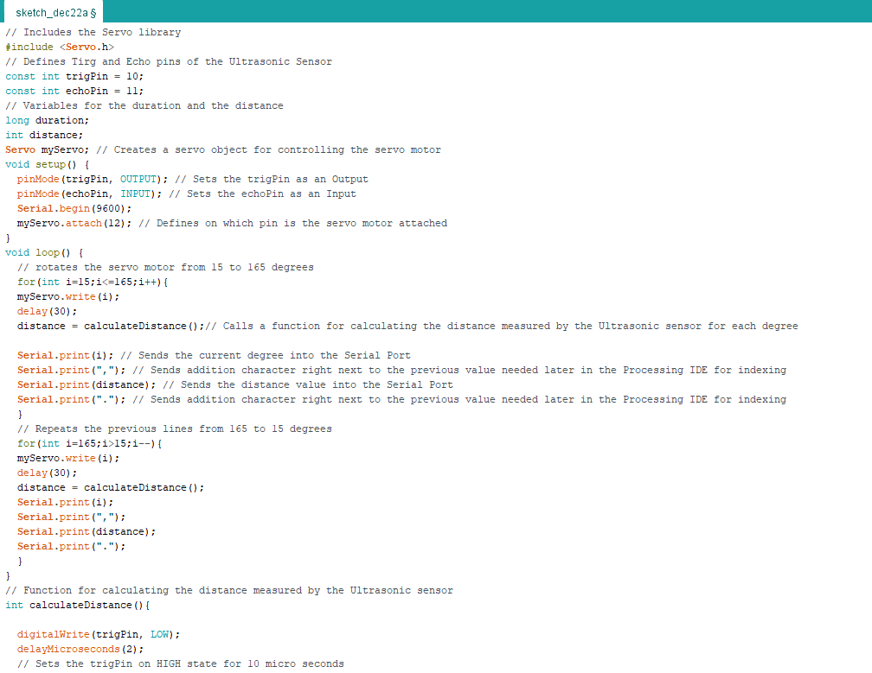
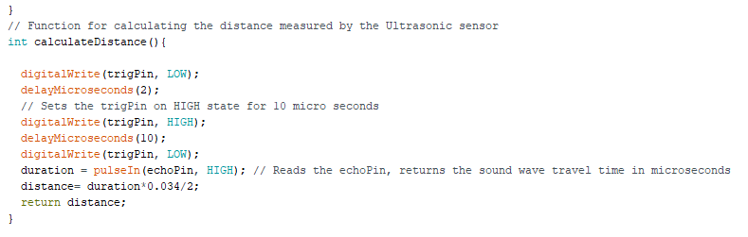

B. Processing Simulation Code
